- (a) An equation for the speed v of longitudinal waves in a thin rod of an elastic solid of
Young modulus E and density is given. Show whether the equation is homogenous or not. [3]

- A student measured the volume of a polymer cylinder by finding its dimensions with a ruler. He recorded his reading as follows:

Diameter of cylinder = (16 ± 1) mm
Height of cylinder = (28 ± 1) mm

  - Find the percentage uncertainty of the volume of the cylinder.

percentage uncertainty = ………..…% [2]

  - Comment on the student’s choice of apparatus. How would you improve on his measurement?

…………………………………………………………………………………………………………...………………………………………………………… [2]

- (a) Figure 2.1 shows a skier being pulled up a slope at constant speed. The tension in the wire pulls the skier with a force of 400 N that acts at 40⁰ to the slope.

Figure 2.1

- Explain with reference to the force acting on the skier why he travels at
constant speed.
………………………………………………………………………………………………………………………………………………………………………………………………………………………………………….. [2]

- Calculate the component of the tension in the wire

- Parallel to the slope

Component: …………………….N

- Perpendicular to the slope

Component: ………………………..N

(b) Discuss the effect on the skier’s motion if the tension in the wire is suddenly increased.
…………………………………………………………………………………………………………………………………………………………………………………………………………………………………………………………………………………………………...[2]

- (a) (i) Define moment of a force about a point

…………………………………………………………………………………………………………………………………………………………………………………………

(ii) Define torque of a couple

……………………………………………………………………………………………………………………………………………………………………………………… [3]

(b) Figure 3.1 shows the steering wheel of a car being acted on by two equal forces
Figure 3.1

  - Calculate the torque acting on the wheel due to these forces.

Torque …………………….. [2]

  - Explain whether the steering wheel is in equilibrium when subjected to these two forces.
…………………………………………………………………………………………………………………………………………………………………………………………………………………………………………………. [3]

- (a) Define Young Modulus of a material.

……………………………………………………………………………………………………………………………………………………………………………………… [2]

(b) A metal wire of length 1.80 m is clamped vertically and a load is applied so that it extends 0.55 mm. The cross-sectional area of the wire is 1.2 x 10⁻⁷ m² and the Young Modulus of the metal is 2.0 x 10¹¹ Pa.

  - Calculate the strain

Strain= ……………… [2]

  - Calculate the force applied

Force =………………. N [2]

- (i) Determine the extension produced on a second metal wire that has the same dimensions as the wire in part (b), has the same load applied but is made from a material that has half the Young Modulus value.

Extension = ………………..mm [2]

  - State one assumption made
...................................................................................................................................................................................................................................................[1]
5. A microwave source is directed towards a metal plate with two narrow vertical slits. A receiver is slowly moved along the line XY as shown in Fig. 5.1.
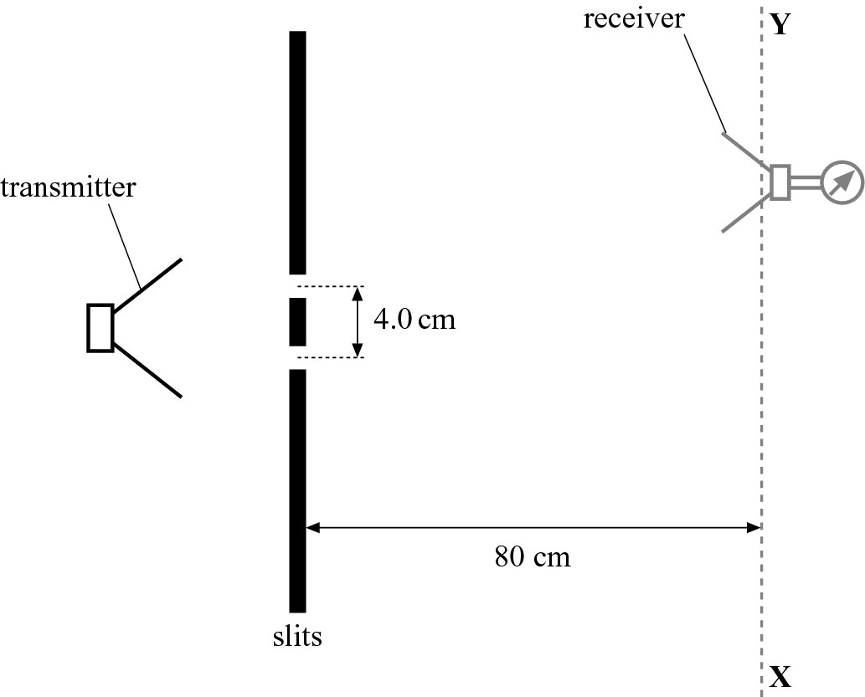
Fig. 5.1
(a) Explain why the receiver registers a series of maxima and minima.
……………………………………………………………………………………………………………………………………………………………………………………………………………………………………………………………………………………………………[3]

(b) The wavelength of the microwaves is 2.8 cm. The separation between the slits is 4.0 cm and the receiver is a distance of 80 cm from the slits. Calculate the separation between adjacent maxima.

x = …………………cm [3]

(c) State and explain the effect on your answer to (b) when:
(i) the separation between the slits is halved
………………………………………………………………………………………………………………………………………………………………………..[2]
(ii) the distance between the slits and the receiver is doubled.
………………………………………………………………………………………………………………………………………………………………………..[2]
6. The Fig. 6.1 shows two parallel horizontal plates separated by a vertical distance of 3.0 cm. The potential difference between the plates is 600 V.
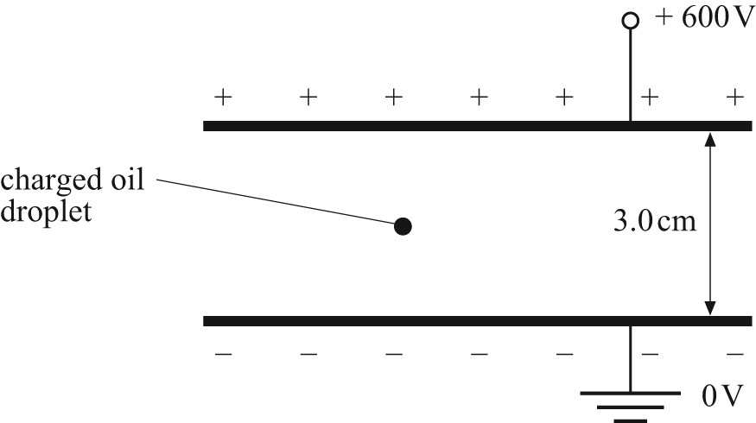
Fig. 6.1
(a) Calculate the magnitude and direction of the electric field between the plates.

Electric field: ……………..Vm⁻¹
Direction: ……………………………..
[3]
(b) Describe the electric field between the plates.
…………………………………………………………………………………………………………………………………………………………………………………………………[2]
(c) An oil droplet of weight 6.4 × 10⁻¹⁵ N is held stationary between the two plates.
(i) State whether the charge on the droplet is positive or negative.
Explain your answer.
…………………………………………………………………………………………………………………………………………………………………………………………………………………………………………………………………………………….[2]
(ii) Determine the charge on the oil droplet.

Charge: ……………….. [2]

7. The Fig. 7.1 shows a potential divider circuit. The voltmeter has infinite resistance and the battery has negligible internal resistance.
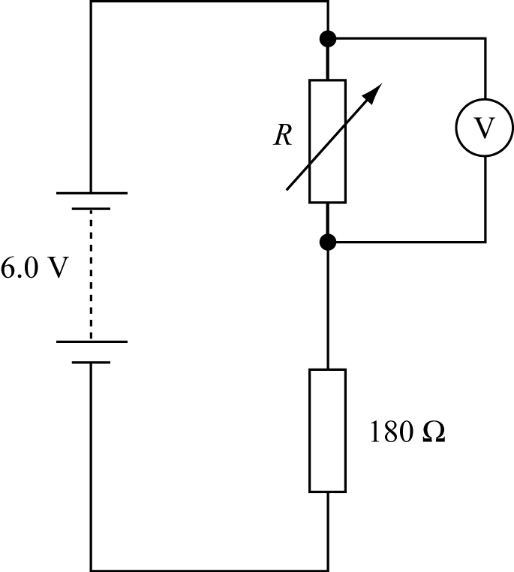
Fig. 7.1

(a) The variable resistor is set on its maximum resistance of 200 Ω. Calculate the
voltmeter reading.

Voltmeter reading: …………………..V [3]

(b) The resistance R of the variable resistor is gradually altered from its maximum resistance value of 200 Ω to zero. Draw a sketch graph in Fig. 7.2 to show how the voltmeter reading changes with I.
V/ V

I/ A

Fig. 7.2
[3]

8. In an α-particle scattering experiment, α-particles are fired towards a thin gold foil.
(a) The Fig. 8.1 shows three α-particles approaching a gold nucleus in the foil. In the diagram
complete the paths of the α-particles. [3]

α
α
gold
nucleus
α

Fig. 8.1

(b) Explain why the α-particle comes closer to the gold nucleus when the α-particle is initially faster.
……………………………………………………………………………………………………………………………………………………………………………………………………………………………………………………………..[2]

